HBASE Commands

Objective: To create and execute hbase commands for the following operations

To open hbase terminal

[training@localhost ~]$ **hbase shell**

Output:

Hbase(main):001:0>

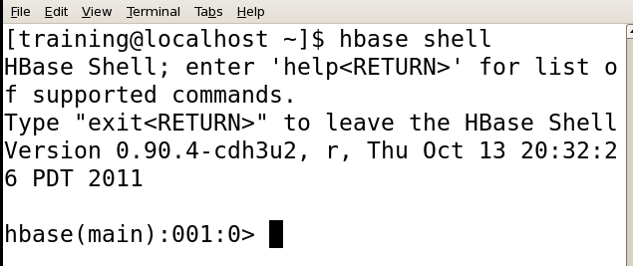

1. Hbase(main):001:0>**STATUS**

Shows the cluster status

Output:

Status ‘simple’

Status ‘summary’

Status ‘detailed’

1. **VERSION**

Shows the current version of hbase.

Output: Hbase(main):001:0>



**4) CREATE TABLE**

create<tablename>, <columnfamilyname1><columnfamilyname2>

Hbase(main):001:0>create 'emp', 'personal data', 'professional data'

put 'emp','1','personal data:name','raju'

put 'emp','1','personal data:city','hyderabad'

put 'emp','1','professional data:designation','manager'

put 'emp','1','professional data:salary','50000'

put 'emp','2','personal data:name','sathish'

put 'emp','2','personal data:city','bangalore'

put 'emp','2','professional data:designation','professor'

put 'emp','2','professional data:salary','60000'

put 'emp','3','personal data:name','muthu'

put 'emp','3','personal data:city','chennai'

put 'emp','3','professional data:designation','analyst'

put 'emp','3','professional data:salary','20000'

**5. LIST**

To List all the tables

Hbase(main):001:0>list

6. **DESCRIBE**

To describe the table.

describe 'emp'

**7. DISABLE**

To delete a table or change its settings, you need to first disable the table using the disable command.

disable 'emp'

is_disabled command is used to find whether a table is disabled.

**8. DROP**

To Drop the table

drop 'emp'

9. **ENABLE**

To find whether a table is enabled.

enable 'emp'

The following command verifies whether the table named **emp** is enabled. If it is enabled, it will return true and if not, it will return false

* is_enabled ‘emp’

10. **Scan**

command is used to view the data in HBASETable. Using the scan command, we can get the table data.

scan 'emp'

ROW COLUMN + CELL

1 column = personal data:city, timestamp = 1417521848375, value = hyderabad

1 column = personal data:name, timestamp = 1417521785385, value = ramu

1 column = professional data:designation, timestamp = 1417585277,value = manager

1 column = professional data:salary, timestamp = 1417521903862, value = 50000

1 row(s) in 0.0370 seconds

11 .DROP

Deletes a table. Before dropping a table, disable the table.

hbase(main):018:0> disable 'emp'

0 row(s) in 1.4580 seconds

hbase(main):019:0> drop 'emp'

0 row(s) in 0.3060 seconds

**12. GET**

To get the particular record

get method > get 'emp', '1'

**13. DELETE**

To delete the particular record

delete ‘<table name>’, ‘<row>’, ‘<column name >’, ‘<time stamp>’

delete 'emp', '1', 'personal data: city’,1417521848375

deleteall ‘emp’

deletes all the records in the table ‘emp’

**14. COUNT**

The number of rows of a table is counted using the count command. Its syntax is as follows:

count ‘<table name>’

Example

count 'emp'

**15. TRUNCATE**

This command disables drops and recreates a table. The syntax of **truncate** is as follows:

hbase> truncate 'table name'

truncate 'emp'